Cranberry Bog Restoration (Fresh Pond) PIT Tagging
- Freshwater steam Beaver Dam Brook confluence with Cape Cod Bay providing ecosystem connectivity between marine and freshwater habitats, and passage for spawning river herring populations.
(See video file of stream confluence with Cape Cod Bay)

- River herring being collected at PIT Tagging station (passive integrated transponder, PIT) using weir nets as they enter the restoration site in Beaver Dam Brook.

- PIT tagging fish as they enter the restoration site in Beaver Dam Brook

- River Herring swimming upstream in Beaver Dam Brook
(See video file of fish swimming)

- (BUILDING) Citizen science groups learning to construct and install PIT antennas. PIT Tag antennas and passive transmitters are like the EZ-Pass on the highway, a fish passes through the antenna and an unique code, date, time, and location is recorded.
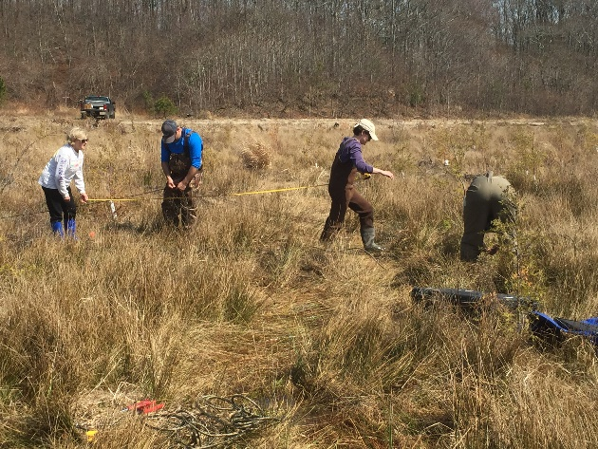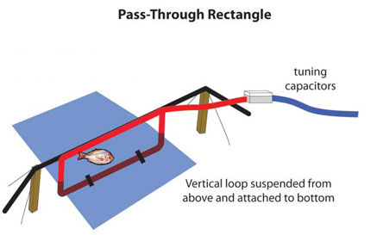

- INSTALLATION Installing and programming PIT antennas. The system uses either battery, solar, or hard-wired power sources depending on availability and access.
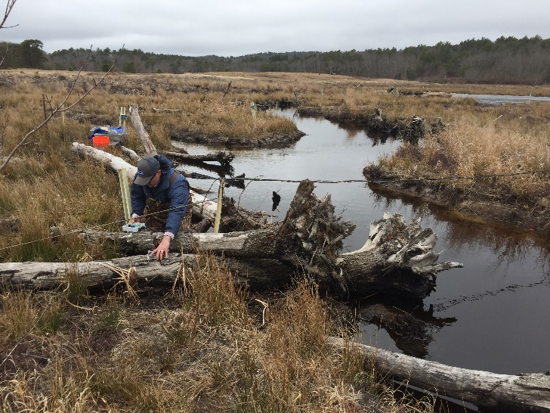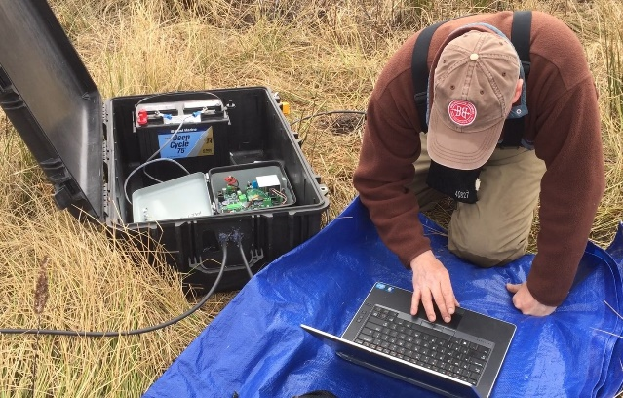

- Fish passage restoration often involves improving culvert structures. This culvert extends under the roadway enabling fish to continue migrating upstream to their spawning habitat in Fresh Pond.
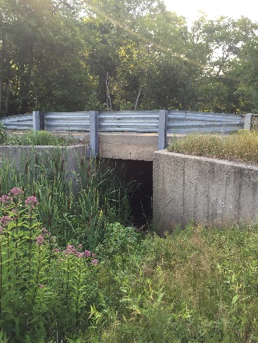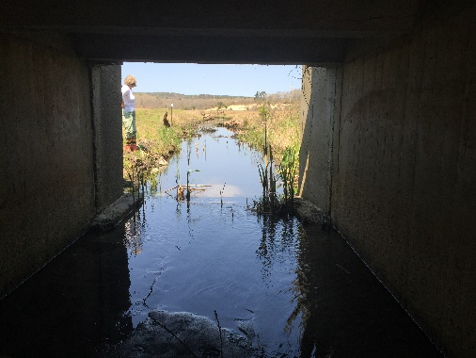

- River herring swimming upstream in the last section of channel that connect to the Fresh Pond spawning habitat.
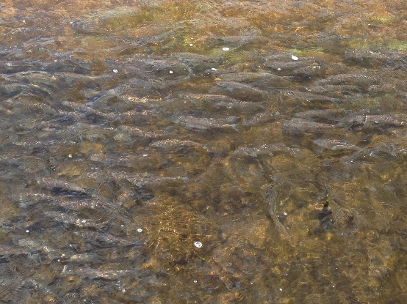

9. Channel outflow from Fresh Pond
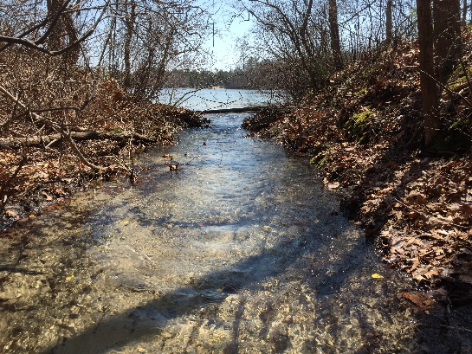
10. FRESH POND Fresh Pond river herring spawning habitat. River herring are little packets of energy moving transporting resources back and forth, connecting freshwater and marine ecosystems through annual river herring spawning migrations.

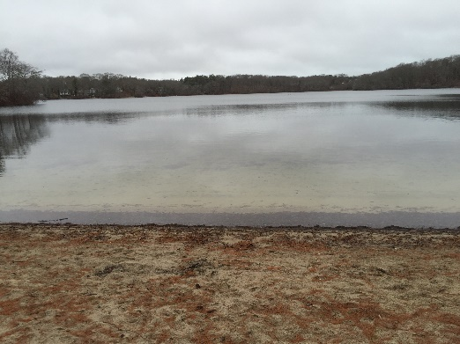…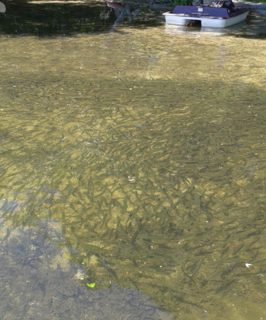 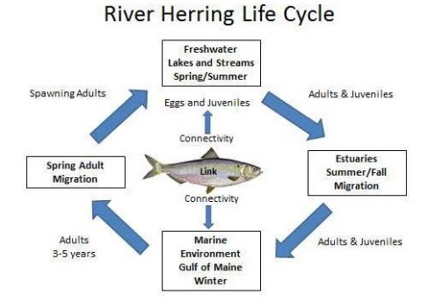

11. Collecting freshwater predator fish for river herring food web modeling.

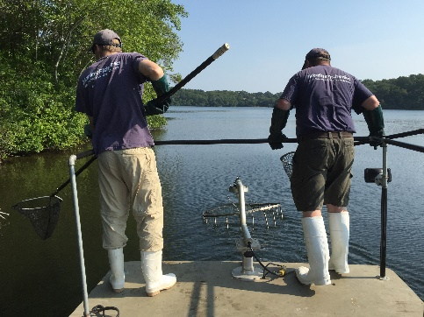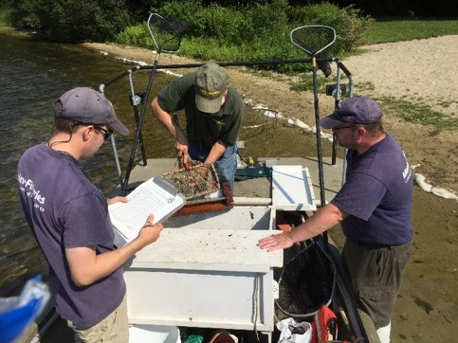

12. Sonar mapping lake bathymetry for river herring habitat and resource assessments

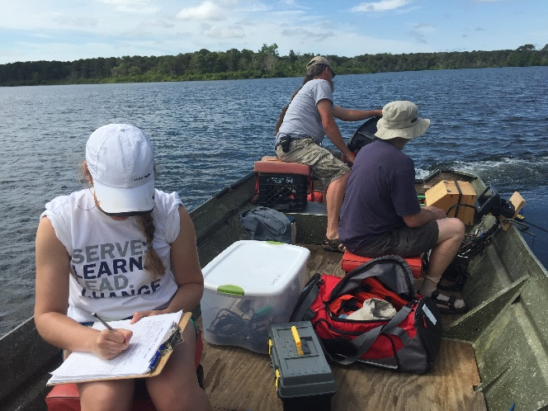

Video: River herring resource outreach video

